WBJEE
West Bengal Joint Entrance Examination

About the exam-

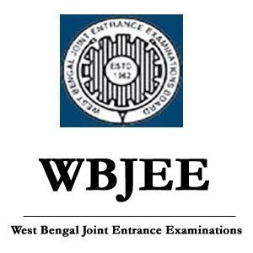

- The West Bengal Joint Entrance Examinations Board administers the West Bengal Joint Entrance Examination, also known as the WBJEE, which is a state-controlled, centralised test for admission to numerous private and public engineering institutes in West Bengal.

- After completing grade 12, students take the test to be admitted to graduation (also known as bachelor's) courses. Anyone who completed the physics, chemistry, and mathematics courses in the pure science and vocational 10+2 streams at the plus two level is eligible to sit the exam.

Overview/Highlights of this exam-

Particulars | Details
Name of the examination | West Bengal Joint Entrance Examination
Exam conducting authority | West Bengal Joint Entrance Examination Board
Frequency of the exam | Once a year
Courses offered through the exam | Admission to undergraduate Engineering Colleges of West Bengal
Examination level | State level
Medium of examination | English and Bengali
Mode of the examination | pen-paper based
Exam official website | wbjeeb.in/wbjee

Eligibility criteria for this exam-
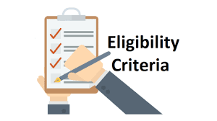
NATIONALITY

- The candidate needs to be an Indian national.

AGE REQUIREMENTS
- To sit for the exam, a candidate must be at least 17 years old (as of December 31, 2022) or have been born on or before that day. There is no maximum age for taking the exam.

- However, as of December 31, 2022, the minimum age requirement for enrollment to the Marine Engineering Course is 17 years old, and the maximum age requirement is 25 years old.

Paper pattern & marking scheme of the examination -

Particulars | Details
Mode | Offline (pen-and-paper-based test)
Duration | 4 hours (2 hours for each paper)
Medium of Exam | English and Bengali
Sections | Paper 1 - Mathematics  Paper 2 - Physics and Chemistry
Type of Questions | Multiple Choice Questions
Total Number of Questions | 155 Questions

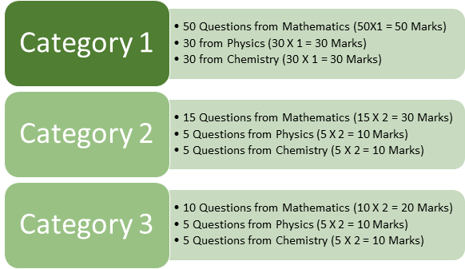

- Category I: One mark will be given for each accurate response. A wrong answer results in a deduction of one-fourth of a mark. Any combination of responses that include more than one option will be deemed wrong and receive a score of -1/4 (25% negative).

- Category II: A correct response earns two marks but only one option is acceptable. A wrong answer will receive -1/2 (25% negative) marks. Any combination of responses that include more than one option will be deemed wrong and receive a score of -1/2 (25 percent negative).

- Category III: A few selections might be accurate. Only accurate answers will earn you two (two) marks. There are no failing grades.

Available seats & participating institutions-

S.No | Name of Institute
1 | Abacus Institute Of Engineering & Management, Mogra, Hooghly
2 | Academy Of Technology, Adisaptagram, Hooghly
3 | Asansol Engineering College, Asansol, Burdwan
4 | B.P. Poddar Institute Of Management & Technology, Kolkata
5 | Bankura Unnayani Institute Of Engineering, Bankura
6 | Bengal College Of Engineering & Technology, Durgapur
7 | Bengal College Of Engineering, Durgapur
8 | Bengal Institute Of Technology & Management, Santiniketan
9 | Bengal Institute Of Technology, Dhapa, Kolkata
10 | Birbhum Institute Of Engineering & Technology, Suri, Birbhum
11 | Budge Budge Institute Of Technology, Budge-Budge
12 | Calcutta Institute Of Engineering & Management, Tollygunge, Kolkata
13 | Calcutta Institute Of Technology, Uluberia, Howrah
14 | Camellia Institute Of Engineering And Technology, Bud Bud, Burdwan
15 | Camellia Institute Of Technology & Management, Bainchi, Hooghly
16 | Camellia Institute Of Technology, Badu Road, Madhyamgram
17 | Camellia School Of Engineering & Technology, Barasat
18 | College Of Engineering And Management, Kolaghat
19 | Dr. B. C. Roy Engineering College, Durgapur
20 | Dr.Sudhir Chandra Sur Institute Of Technology And Sports Complex, Dum Dum
21 | Dream Institute Of Technology, Bishnupur, 24-Parganas-South
22 | Dumkal Institute Of Engineering & Technology, Dumkal, Murshidabad
23 | Durgapur Institute Of Advanced Technology & Management, Durgapur
24 | Elitte College Of Engineering, Mahispota, Sodepur
25 | Future Institute Of Engineering & Management, Sonarpur
26 | Future Institute Of Technology, Boral, Garia
27 | Gargi Memorial Institute Of Technology, Baruipur, Kolkata
28 | Global Institute Of Management And Technology Krishnanagar, Nadia
29 | Greater Kolkata College Of Engineering & Management, Baruipur
30 | Guru Nanak Institute Of Technology, Panihati, Sodepur
31 | Haldia Institute Of Technology, Haldia, Purba Medinipur
32 | Hemnalini Memorial College Of Engineering, Haringhata
33 | Heritage Institute Of Technology, Kolkata
34 | Hooghly Engineering & Technology College, Hooghly
35 | Ideal Institute Of Engineering, Kalyani
36 | Imps College Of Engineering & Technology, Malda
37 | Institute Of Engineering & Management,Salt Lake
38 | Institute Of Science And Technology, Paschim Medinipur
39 | Jis College Of Engineering, Kalyani, Nadia
40 | Jld Engineering And Management College, Baruipur
41 | Kanad Institute Of Engineering & Management, Mankar, Burdwan
42 | Mallabhum Institute Of Technology, Bishnupur, Bankura
43 | Mckv Institute Of Engineering, Liluah, Howrah
44 | Meghnad Saha Institute Of Technology, Kolkata
45 | Modern Institute Of Engineering & Technology, Bandel, Hooghly
46 | Murshidabad College Of Engineering & Technology, Murshidabad
47 | Narula Institute Of Technology, Agarpara, Kolkata
48 | Neotia Institute Of Technology Management And Science ,D.H.Road
49 | Netaji Subhash Engineering College, Garia, Kolkata
50 | Nshm Knowledge Campus, Durgapur Group Of Institutions
51 | Omdayal Group Of Institutions, Uluberia, Howrah
52 | Pailan College Of Management & Technology, Pailan Park
53 | Rcc Institute Of Information Technology, Kolkata
54 | Regent Education And Research Foundation, Barasat, Kolkata
55 | Sanaka Education Trusts Group Of Institutions, Durgapur, Burdwan
56 | Saroj Mohan Institute Of Technology, Guptipara, Hooghly
57 | Seacom Engineering College,Sankrail,Howrah
58 | Siliguri Institute Of Technology, Siliguri
59 | St. Mary's Technical Campus Kolkata, Barasat
60 | St. Thomas College Of Engineering & Technology, Khidirpur, Kolkata
61 | Supreme Knowledge Foundation Group Of Institutions, Mankundu, Hooghly
62 | Surendra Institute Of Engineering & Management, Siliguri
63 | Swami Vivekananda Institute Of Science & Technology, Sonarpur
64 | Techno Engineering College Banipur, 24 Parganas-North
65 | Techno International Batanagar
66 | Techno International New Town, Rajarhat, New Town
67 | Techno Main Salt Lake, Sector-V, Salt Lake

WBJEE 2022 Participating Institutes- Private Pharmacy Colleges (19)
S.No | Name of Institute
1 | Anand College Of Education, Debra, Paschim Medinipur
2 | Bcda College Of Pharmacy & Technology, Hridaypur, Madhyamgram
3 | Bengal College Of Pharmaceutical Technology, Dubrajpur, Birbhum
4 | Bengal College Of Pharmaceutical Science & Research, Durgapur
5 | Bengal School Of Technology, Sugandha, Hooghly
6 | Bharat Technology, Uluberia, Howrah
7 | Birbhum Pharmacy School, Hetampur, Birbhum
8 | Calcutta Institute Of Pharmaceutical Tech. & Allied Health Sciences, Uluberia
9 | Dr. B. C. Roy College Of Pharmacy And Allied Health Sciences, Durgapur
10 | Eminent College Of Pharmaceutical Technology, Barasat
11 | Gitanjali College Of Pharmacy, Lohapur, Birbhum
12 | Global College Of Pharmaceutical Technology, Krishnanagar
13 | Gupta College Of Technological Sciences, Asansol, Burdwan
14 | Guru Nanak Institute Of Pharmaceutical Science And Technology, Sodepur
15 | Haldia Institute Of Pharmacy, Haldia
16 | M.R. College Of Pharmaceutical Science And Research, Bira, Ashoknagar
17 | Netaji Subhash Chandra Bose Institute Of Pharmacy, Chakdah. Nadia
18 | Nshm Knowledge Campus, Kolkata Group Of Institutions, Kolkata
19 | P.G. Institute Of Medical Sciences, Chandrakona

WBJEE Participating Institutes 2022- State Government Engineering Colleges (8)
S.No | Name of Institute
1 | Cooch Behar Government Engineering College, Cooch Behar
2 | Government College Of Engineering And Leather Technology, Kolkata
3 | Govt. College Of Engg. & Textile Technology, Berhampore
4 | Govt. College Of Engineering & Ceramic Technology, Kolkata
5 | Govt. College Of Engineering & Textile Technology, Serampore
6 | Jalpaiguri Government Engineering College, Jalpaiguri
7 | Kalyani Government Engineering College, Kalyani, Nadia
8 | Ramkrishna Mahato Government Engineering College, Purulia

WBJEE 2022 Participating Institutes- State Government Pharmacy College (1)
S.No | Name of Institute
1 | Institute Of Pharmacy, Jalpaiguri

WBJEE Participating Institutes 2022- Other Government Engineering College (1)
S.No | Name of Institute
1 | Ghani Khan Choudhury Institute of Engineering & Technology, Malda

WBJEE 2022 Participating Institutes- University/University Department (11)
S.No | Name of Institute
1 | Aliah University, New Town
2 | Bidhan Chandra Krishi Viswa Vidyalaya, Mohanpur, Nadia
3 | Department Of Jute And Fibre Technology, Calcutta University
4 | Jadavpur University
5 | Kazi Nazrul University, Asansol
6 | Maulana Abul Kalam Azad University Of Technology, West Bengal
7 | University Institute Of Technology, Burdwan (Self Financing Course)
8 | University Of Calcutta (College Of Science, Technology And Agriculture)
9 | University Of Kalyani, Science Instrumentation Centre
10 | Uttar Banga Krishi ViswaVidyalaya
11 | West Bengal University Of Animal & Fishery Sciences

WBJEE Participating Institutes 2022- Private University (9)
S.No | Name of Institute
1 | Adamas University, Barasat
2 | Brainware University, Barasat
3 | Jis University, Agarpara
4 | School Of Pharmacy, Techno India University, Salt Lake
5 | Seacom Skills University, Bolpur
6 | Sister Nivedita University, New Town
7 | Swami Vivekananda University
8 | Techno India University, Salt Lake
9 | The Neotia University, Diamond Harbour Road, Sarisha

Available Seats For WBJEE Entrance Exam-

Serial No. | List of colleges | No.of colleges | No.of Seats available
1. | Govt. Engineering/Pharmacy Colleges | 10 | 2053
2. | Private Engineering/Pharmacy Colleges | 86 | 28493
3. | Govt Universities/Departments | 11 | 2283
4. | Private Universities | 9 | 2062

Important events & their dates related to exam-

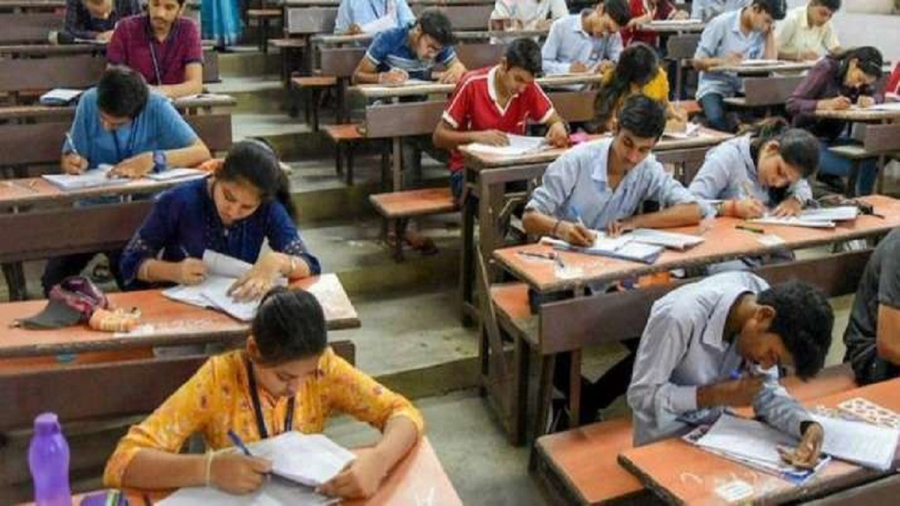

Events | Dates
Registration open for the exam | December
Last date for registration | January
Admit card releasing date | April
Exam date | April
Online declaration of answer key | June
Results of the exam

Exam Application process -
Register for the WBJEE online in 2022. Candidates must first complete the WBJEE registration process for 2022 by following the instructions provided:

STEP 1 - Visit the WBJEE 2022 official website at wbjee.nic.in.

STEP 2 - Select the link for "New Registration."

STEP 3- Enter information such as your name, your parents' names, your birthdate, your gender, the sort of identification you have, and your phone number.

STEP 4 - additional contact information (address, district, state, PIN code, email ID, mobile number, etc.)

STEP 5 - With the response, create a password and security question.

STEP 6- Click "Submit" after reviewing the information you gave during WBJEE registration.

And selection procedure of the exam-

- Candidates will be chosen based on how well they did on the entrance exam. Students who pass the exam should register for online counselling sessions and pay the counselling cost at Allahabad bank using an e-challan.

